

**User manual**

**Anti-drone system**

**Form: T REX SQUAD**

Camilla Colas - Ye Chen - Adam Wilhelm –

Clémence Lorant - Bandiougou N’Diaye - Weimin Cao

16/11/202

Table des matières

Preface 3

1. General information 3

1.1 Project goals and objectives 3

1.1 General Operating Instructions 3

2. Current working environment 4

2.1 Hardware Environment 4

2.2 Potential problem 7

2.3Potential improvements 8

3. System Function Description 8

3.1 Operation of engine 8

3.2 PIXY2 target identification 10

3.3 Weapon system 10

# Preface

The aims of this user manual is to describe the functions of Anti drone system and help users. This article is suitable for users who want to know the specific working principle of the EV3 Anti drone system.

# General information

## 1.1 Project goals and objectives

The role of the EV3 robot is to monitor a defined rectangular airbase. The robot fires a ball on a drone (red tennis ball).

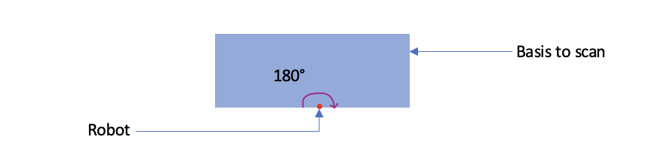

The robot must be located in the center of one of the edges of the base in order to be able to scan the whole area. Once the robot has found a drone, it fires a bullet on it. The drone must be 30 cm away from the robot.

The whole machines is made of plastic Lego parts and electronic, so it can’t be bumped, beaten or wet

## 1.1 General Operating Instructions

The code implemented in the program can be found on GitHub platform, which is convenient for users to better understand the meaning of the program. To work on the EV3 robot, you can use the EV3 central controller. All the code is in python language.

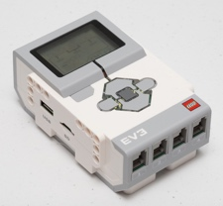

*Ev3 controller*

To run the test program, press the middle button to start and select “’**test.py”** . After starting the test.py program, wait for three to four seconds, and the machine will respond. First, the PIXY2 camera will be turned on and initialized (wait for few seconds), then, the PIXY2 will turn thanks to the engine, left or right to determine the target (the red ball), and then PIXY2 will lock the target, stop rotating and give the target corresponding PIXY2 distance. After determining the position of the target, the program will drive the motor to run the weapon system to attack the remote target (maximum range is one meter distance).

# 2. Current working environment

## 2.1 Hardware Environment

**THE EV3 :**



*Ev3 controller*

The biggest feature of EV3 is that it can be programmed without using a computer. Indeed, EV3 is equipped with a "smart brick" that users can use to edit various instructions for the robot.

Function introduction: The new generation of NXT blue control - EV3.

Its button can blink, color light state indicates the state of EV3, higher resolution black and white display, built-in sound player, USB port, a mini SD card reader, four input ports and Four output ports. It supports USB2.0, Yiya and Wi-Fi to communicate with the computer. There is also a programming interface for programming and data Log upload and download. ompatible with mobile devices, <Android, TOS) powered by AA batteries or EV3 rechargeable DC batteries

**Specifications**:

Processor : ARI 9 processor 300MHZ-based on Linux operating system

Input ports : Four

Output ports: Four

Sampling rate : 1000/s

RAM Storage : 64MB

ROM Storage : 16MB

Support for mini SD card expansion : up to 32 GB

Keys : Six buttons that emit three colors. And the active state is indicated by the color. Screen : Resolution 178*128 pixels, better view detailed graphics and sensor data

Expansion : through the standard USB on the left side of EV3 (EV3 has two USBs, one is miniUsB for program download, The quasi-USB is used for expansion, and can be connected to external devices such as external Wi-Fi and Bluetooth adapters. Communication : can use USB2.0, Wi-Fi communication

Batteries : Accepts six AA batteries, or the original 2050mAh lithium battery. mark Servo Motors : Not much different from previous NXT servo motors. The main difference is the appearance, which is easier to connect.

**THE PIXY2 CAMERA :**

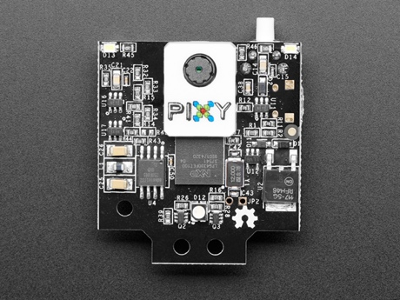

Pixy2

The Pixy2 camera make image recognition easier, supports multi-object recognition, and has powerful multi-color color recognition and color block tracking capabilities.

**Specifications**:

Processor: NXP NXP LPC4330, 204 MHz dual-core.

Image sensor: Aptina MT9M114, 1296×976 resolution, integrated image stream processor.

Lens field of view: horizontal 60 degrees, vertical 40 degrees.

Power consumption: 140 mA typical.

Power input: USB input (5V) or Vin input (6V~10V).

RAM: 264K bytes.

Flash memory: 2M bytes.

Available data outputs: UART serial, SPI, I2C, USB, digital, analog.

Dimensions: 1.5" x 1.65" x 0.6".

Weight: 10g.

Integrated light source: about 20 lumens.

**THE MOTOR :**

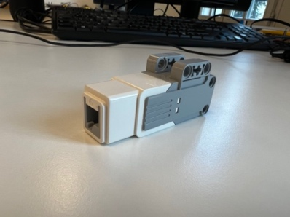

Motor

The motors run through the program, combining various gears and Lego parts, and then the parts of the machine move independently.

**Specification :**

Speed measurement feedback accuracy : 160- 170 RPM

Operating torque approx : 30 oz *in

Stall torque : 60oz*in

Micro servo motor: Compared with Wang Chang's servo motor, it has smaller torque, higher speed, faster response time and smaller volume.

**THE LAUNCHER :**

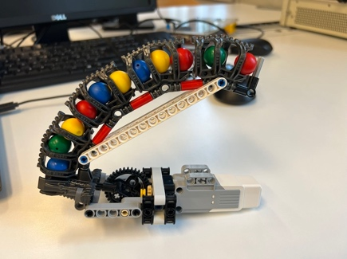

Launcher

The launcher is spliced by Lego parts, and there are a certain number of marbles inside the launcher. Through the motor, the marbles can be pushed out to hit the target.

We added two buttons to know the angle of the launcher and the camera. The motor rotates on the Z axis and must know its position from 0° to 180°, so the motor must turn right to activate the first button and know the 0 position, then turn left to know the 180 position. These are two very sensitive push buttons, at the slightest touch, it picks up the information.

Two other motors permit to rotate from 0° to 45° vertically.

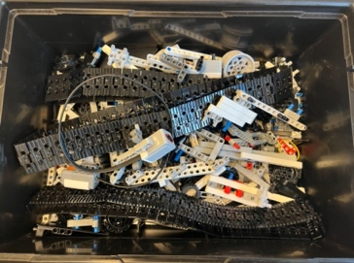

All sorts of Lego parts make up the robot and obviously each part is essential.

## 

## 2.2 Softaware Environment

For the shooting part:

When one or more targets are found, that is, when global Flag_Shoot is true, the code runs to shoot. From the code point of view, the motor speed runs at the speed of 100, and the running time is two seconds.

For the tracking part:

For the screen captured by pixy2, the maximum value of the left and right range is 318, and the maximum value of the upper and lower range is 208. So at the middle position is 168. But when it is 168, pixy2 is unstable and the picture is very shaken, so the value should be set between 148-168. If it is greater than 168, then the motor moves to the right. If it is less than 168, the motor moves to the left. Similarly, It is also necessary to find a stable state in the range of up and down movement.

## 2.3 Potential problem

## Some parts must rotate (PIXY2), thanks to gears. If a gear is damaged or out of place, it can make the rotation less efficient.

## The shelf life of the product depends on the shelf life of the LEGO parts. Because the whole machine is spliced by Lego parts, so if the parts are not replaced for a long time, the plastic parts may soften or even break under different environments, and the parts need to be replaced at this time.

## 2.4 Potential improvements

The machine currently produced uses PIXY2 to identify one or more targets and the job of the weapon system is to hit a target (the one at the shortest distance from the robot). In the future environment, the code and the hardware could be improved to be able to hit several targets at the same time.

# 3. System Function Description

## 3.1 Operation of engine

According to the start-up and operation process of the machine, three motors are required to cooperate.

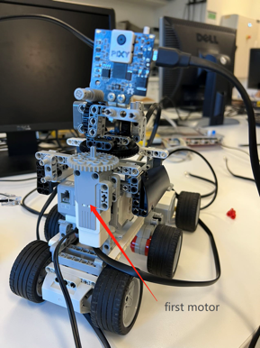

First motor

The first motor is installed vertically and a gear is installed above it. When the motor starts, it drives the gear to rotate. At the same time, another gear with a larger radius is meshed next to this gear. The meshed gears connect to the PIXY2 above via a platform of LEGO parts. Through such mechanical transmission, PIXY has the ability to turn left and right.

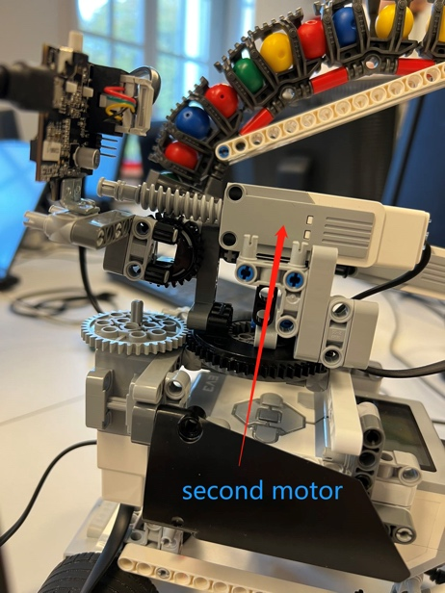

Second motor

The second motor is installed horizontally. The difference from the first motor is that the second motor combines helical threads and gear. When the motor is running, the helical threads drive the gears so that PIXY2 can turn up and down.

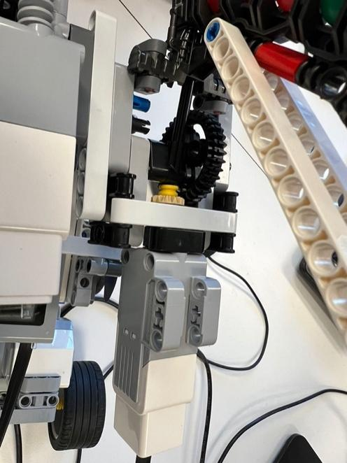

Third motor

The third motor drives the weapon system. The motor is connected to a small gear that rotates horizontally, which is connected to a large vertical gear. Through the meshing of the two gears, the rotation of the small gear will drive the large gear. At the same time, the large gear is connected to the switch device of the weapon system through a lever. When the large gear rotates at a certain angle, the weapon switch is turned on, and the marbles are ejected from it. This process continues as the big gear turns until the marbles are exhausted.

## 3.2 PIXY2 target identification

The PIXY2 used by this machine can identify the red ball as a target for locking. When starting the program, PIXY2 will turn up, down, left, and right through the mechanical structure and motor. When the red ball is recognized, PIXY2 will lock on the target, stop turning, and then show the distance between the target and PIXY2 on the screen of EV3. These operations are all thanks to the python code.

## 3.3 Weapon system

 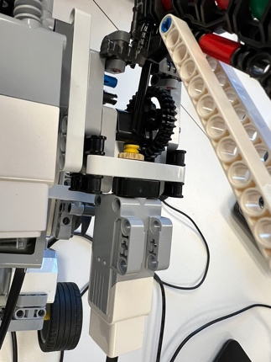

Launcher Motor system

The weapon system includes two parts, the motor system and the launching device.

The motor has been introduced before, here is the explanation of the launcher.

This launcher builds a curved tube for the clip. A certain number of marbles are stored inside. In order to make it stable, LEGO parts are added at the beginning and end of the pipe to make it stable, and the shake of the marbles will not affect the launcher as a whole.